15-10-2023
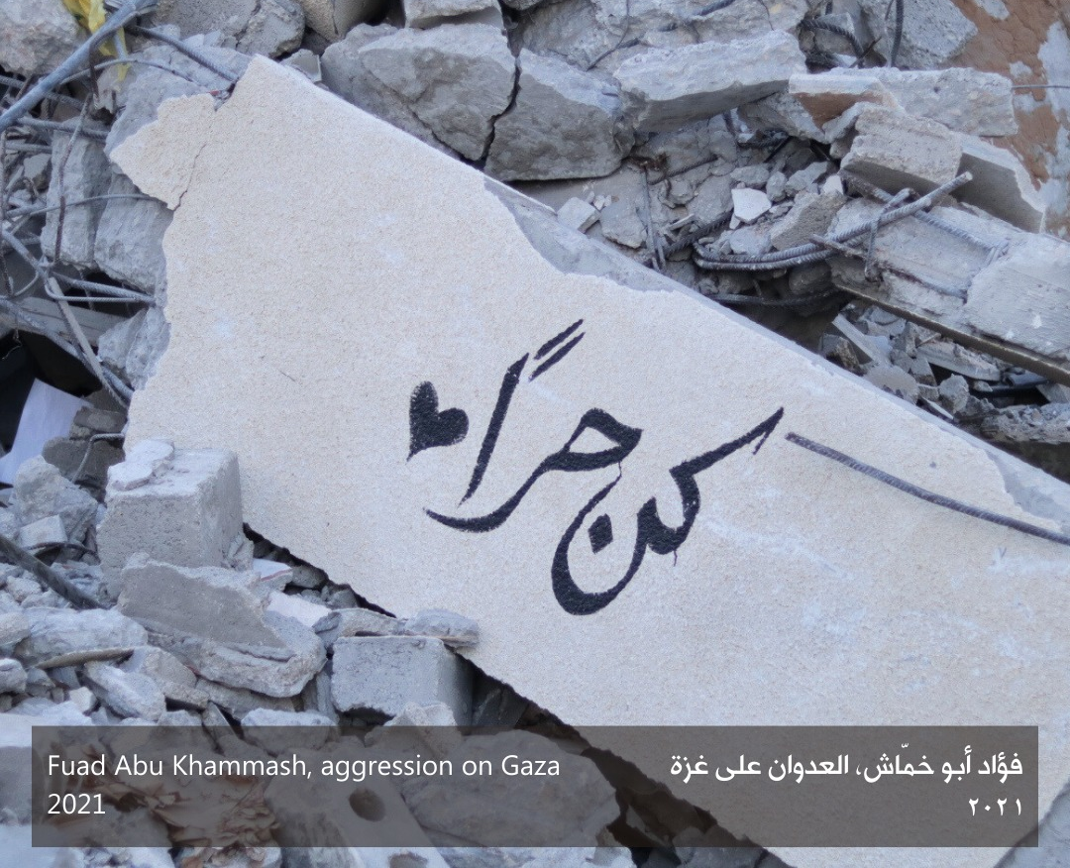

أصدقاء وشركاء ومجتمع رواق الأعزاء،

نرسل إليكم هذه الرسالة وقلوبنا مليئة بالحزن والعجز بينما يواجه الفلسطينيون في قطاع غزة الإبادة الجماعية الكارثية والتطهير العرقي. حتى الآن، قُتل ما يزيد عن ٢٨٠٠ فلسطينياً (من بينهم أكثر من ١٠٠٠ طفلاً) في الغارات الإسرائيلية خلال عشرة أيّام، ويتزايد العدد دقيقة بعد دقيقة. تمّ نزوح أكثر من ٤٠٠ ألف شخص ضمن القطاع بالإضافة إلى تدهور صحة الناس الجسدية والنفسية بشكل كبير ونفاذ الماء والغذاء والوقود عنهم وانتهاك القطاعين الصحي والإعلامي. وهناك تصاعد عنف مستمرّ من جانب الجيش الإسرائيلي والمستوطنين في الضفة الغربية والقدس وأراضي المحتلة عام ١٩٤٨.

علينا أن نقف مع أهلنا في غزة. ندعوكم إلى رفع أصواتكم والضغط من أجل إنهاء هذه الإبادة الجماعية وإنهاء احتلال فلسطين.

عائلة رواق
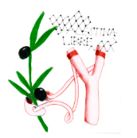
⭕ We do not remain silent about genocide: 🇵🇸 Open letter from Arts Collaboratory ecosystem in Support of Palestinians

Arts Collaboratory is an ecosystem of diverse cultural spaces and arts practitioners, anchored in different territories around the world, including Palestine. We the undersigned, include some of the members from the Arts Collaboratory network and ecosystem, and friends of the network. We share the struggle, in solidarity and with empathy, for a dignified life for all people. We stand in opposition to all colonial oppression and violence.

We stand for freedom.
We stand with Palestine.

The artistic practices Arts Collaboratory are questioning colonial legacies, calling for active liberation/ decolonisation and providing other horizons for such worlds to exist. We come together in resistance, and hopes for liberation. We come together with love for our Palestinian family. We come together in our hope for a free Palestine.

We speak out, with a clear understanding that many cultural organizations and individual art workers are being pushed into silence. We call out the efforts to suppress, distort, and criminalise pro-Palestinian advocacy and We call on the arts community to stand against the silencing of Palestinian voices and of those in solidarity with them.
We are appalled and outraged by the Israeli government's indiscriminate bombings of a densely populated area where 50% of inhabitants are children, and the escalating attacks against Palestinians in the West Bank and Jerusalem.

We are horrified by the intensification of the blockade on Gaza and the forced displacement of millions of people. Cutting all access to basic human needs, such as food, water, and electricity, as well as withholding fuel and medical assistance, constitutes a war crime. Israel, by openly expressing its intent and through its actions, is committing acts of genocide and ethnic cleansing as defined by the Genocide Convention.

We are shocked by the tolerance of, and even support for, the genocide in Gaza by many signatories of the Geneva Convention, and by their failure to live up to their obligations under this agreement. Their continued public support for Israel’s brutal attack on Palestinians not only affects the people of Gaza but has exacerbated hate crimes, Islamophobia and antisemitism across the globe.

Palestinians in all territories are facing increased surveillance, censorship, and a coordinated campaign of vilification by the Israeli Government. They are subjected to attacks, forced displacement, and the constant threat to their lives. This is unjust. This is inhumane. This cannot continue.

We call on the international community to honour the commitment to end genocide and condemn the attacks on Gaza. This begins with a ceasefire, but must culminate with a free Palestine. After 75 years of occupation and apartheid, we say Enough.
We call on all people of conscience to stand against genocide.

Please donate to Gaza relief funds.

Arab Foundation Forum https://arabfoundationsforum.org/gaza-donor-appeal-2023/
Anera: https://support.anera.org/a/palestine-emergency
MECA: https://secure.everyaction.com/b00t33wD-EOVJ1cNTyHixg2
Medical Aid for Palestinians: https://www.map.org.uk/donate/donation-details/484
Taawon: https://www.taawon.org/en/content/gaza-under-attack-2023%E2%80%A6donate-now
Human Appeal
https://humanappeal.org.uk/appeals/gaza-emergency-appeal
Palestine Children's Relief Fund
https://pcrf1.app.neoncrm.com/forms/gaza-relief
Hakini (for mental health support)
https://donorbox.org/psychological-first-aid-for-our-people-from-gaza?mc_cid=bfd116bccb&mc_eid=UNIQID

*We acknowledge the pressure different organizations and art workers are operating under at the moment, you can sign this as an organization or individual.

Signed by the AC ecosystem, a collection of Arts Collaboratory members, individuals and friends:

​​Adriana Rojas, cultural worker, Colombia
Alejandra Rojas, cultural worker, Colombia
Alicia Andares, @lichiambula
Aline Hernádez
Ana Garzón Sabogal - Gestiones Temporales Autónomas
Andrea Stultiens
Andreína Aragoneses / MX-República Checa-PR
Andrés Villalobos
Bambazú- Carmenza Rojas Potes
Casco Art Institute: Working for the Commons
Chupan atashi
Cooperativa Cráter Invertido
Darlyne Komukama
Delphine Buysse - Senegal
Denise Araouzou
Dominique Ratton, Costa Rica
Dulcie Abrahams Altass - artworker and trainee mental health counselor
Fedaa Sultan, Copenhagen, Denmark
Federica bueti
Francisco Baquerizo Racines
Fundación Casa Tres Patios, Colombia
Fundación lugar a dudas , Cali, Colombia
Fundación Más Arte Más Acción
Fundación Mujeres Bachué
Gertrude Flentge
Getse Zato
Helena Chávez Mac Gregor, IIE-Unam Mexico City
Henry Romero Chivatá, Grupo de Trabajo, Colombia
Katayoon Barzegar
Katja. Berends
Kër Thiossane
Kerry Viderot (RAW Material Company Senegal)
Kunci Study Forum & Collective
Liz Miler Kovacs, United States
Luke Cohlen
Madar Collective, Copenhagen, DK
Malika Umarova
Manuela García _ Colombia
María Martinez
Mariana Jurado Rico Colombia
Marina Christodoulidou
Meng Chieh Yu, Taiwan
Mia You
Molemo Moiloa
Mónica de Miranda - hangar
Nadine Wahab, Darb 1718 Egypt
Namaganda Sheillah
Ndeye Filly Gueye (RAW Material Company, Senegal)
Osneyder Valoy
Paloma Contreras Lomas/ Cráter Invertido ecosystem, Mexico
Paula Fleisner, Argentina
Penny Travlou
Platohedro
Radio Tropiezo
RAW Material Company, Dakar
Refilwe Nkomo
reinaart vanhoe, ook_
Richard Bell, Australia
RIWAQ Centre
Rosie Olang'
Rossana Alarcon, colombia
ruangrupa, Jakarta, ID
Sandy Lo, Taiwan
Sarah kazmi
simon kentgens
Su Su van den Boomen
Suzannah Henty, Australia
Syafiatudina (Kunci Study Forum & Collective)
TallerXD/ Mexico cdmx
Teesa Bahana
TEOR/éTica
Violeta Mayoral
Wan Ing Que
Wapke Feenstra
Waysatta Fernandez, Cooperativa Crater Invertido. México
Yolande Zola Zoli van der Heide, Van Abbemuseum, Netherlands
Zeina iaali - Refugee Art Project

